**W6 -** PRACTICE

*Props – List display*

## *At the end of this practice, you should be able to…*

* Display **names dynamically**, using **curly braces** *{xx*}
* Display a **list** of data
* Display **images** dynamically
* Pass data to nested components using **props**

## *How to work?*

* Download **the start code** from the Google classroom
* For each exercise you can either:
  + Run npm install
  + Or move an existing node_modules to the exercise folder *(fastest option!)*

## *How to submit?*

* **Create a repository on GitHub** with the name of this practice:

Ex: C2-S1-PRACTICE

* **Push your final code** on this GitHub repository (if you are lost, [follow this tutorial](https://www.datacamp.com/tutorial/git-push-pull))
* Finally, submit on **Google classroom** your GitHub repository URL

Ex: https://github.com/thebest/ C2-S1-PRACTICE.git

## *Are you lost?*

*You can read the following documentation to be ready for this practice:*

<https://www.w3schools.com/react/react_jsx.asp>

<https://www.w3schools.com/react/react_props.asp>

<https://www.gatsbyjs.com/docs/how-to/images-and-media/importing-assets-into-files/>

<https://www.w3schools.com/react/react_conditional_rendering.asp>

# EXERCISE 1

Your task is to fill the **User** component!

You have a global existing userData, containing a first name, last name, and title.

* Output the **user's first name** and **last name** () inside of the User component's <h2> element.
* Output the **title** inside of the User component's <p> element.

*Note: you can change the user data* 😊

*The finished app could look like this:*

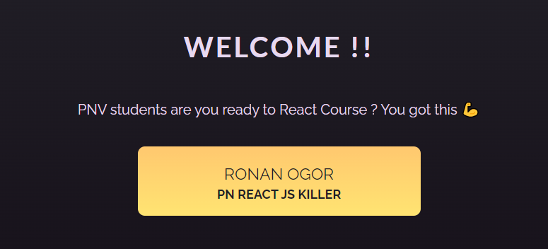

# EXERCISE 2

Well done!

But now we have 2 people to display using this **User** Component: Vinh and My Ngo!

*Note: you CANNOT create 2 components, you need to use the user component and pass data to this component*

*The finished app could look like this:*

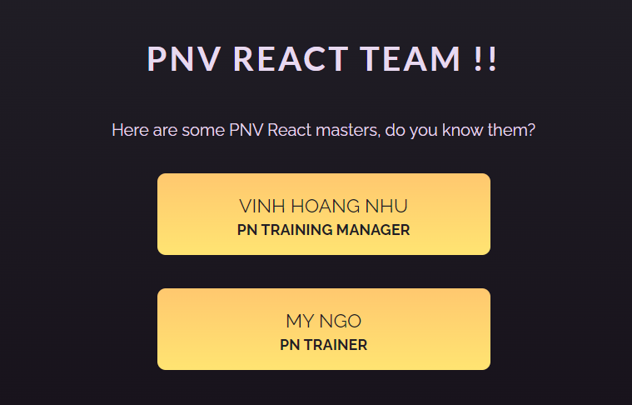

*App will provide a user data to each User component:*

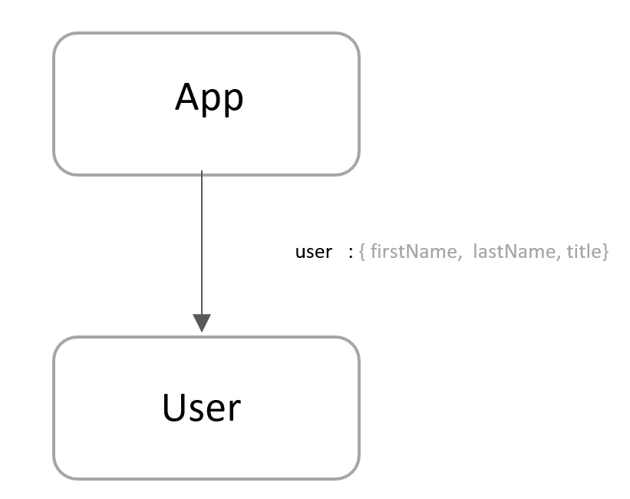

# EXERCISE 3

Amazing!

But now we need to display a bigger list of PNV teachers, using this **User** Component…

The data comes from teachers.js and we already imported this list.

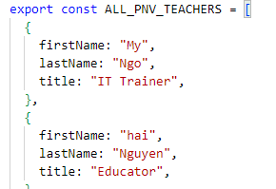

All you need is to loop on this list now and **create a User component for each teacher.**

*Need help? You can* [*read this doc*](https://w3schoolsua.github.io/react/react_lists_en.html#gsc.tab=0) *to render lists with a loop*

*The finished app could look like this:*

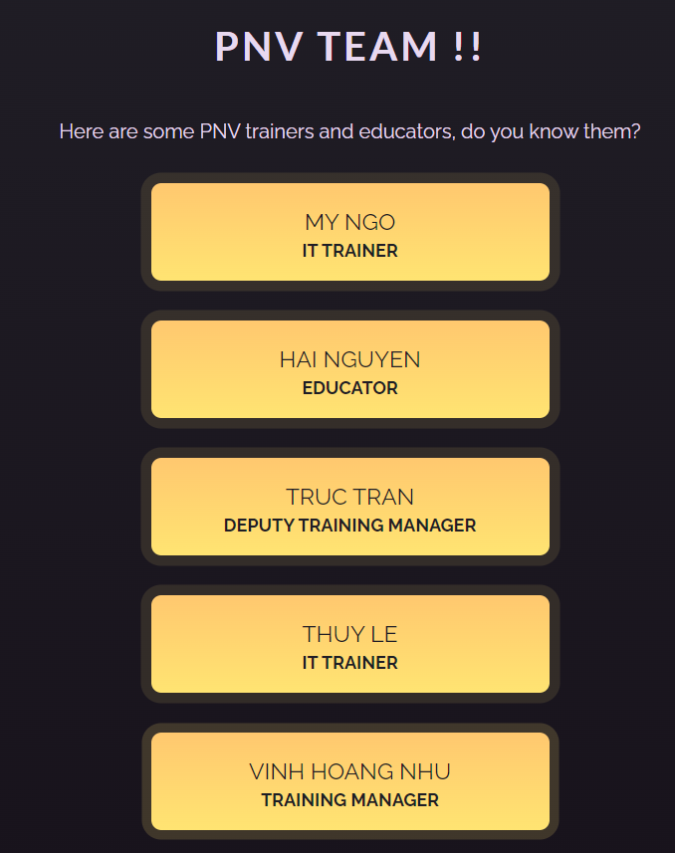

# EXERCISE 4

Amazone!

Now we want to display a **list of places.**

* The places come from data.js and we already imported this list.
* Each place shall be displayed using the **Place** component

The mapping between Place component attribute and the data is the following one:

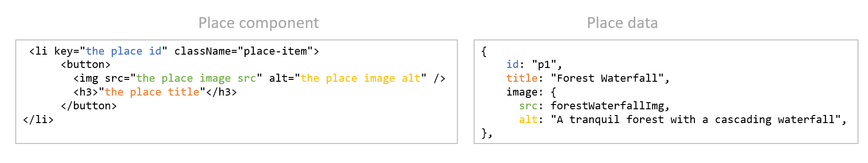

*The finished app could look like this*

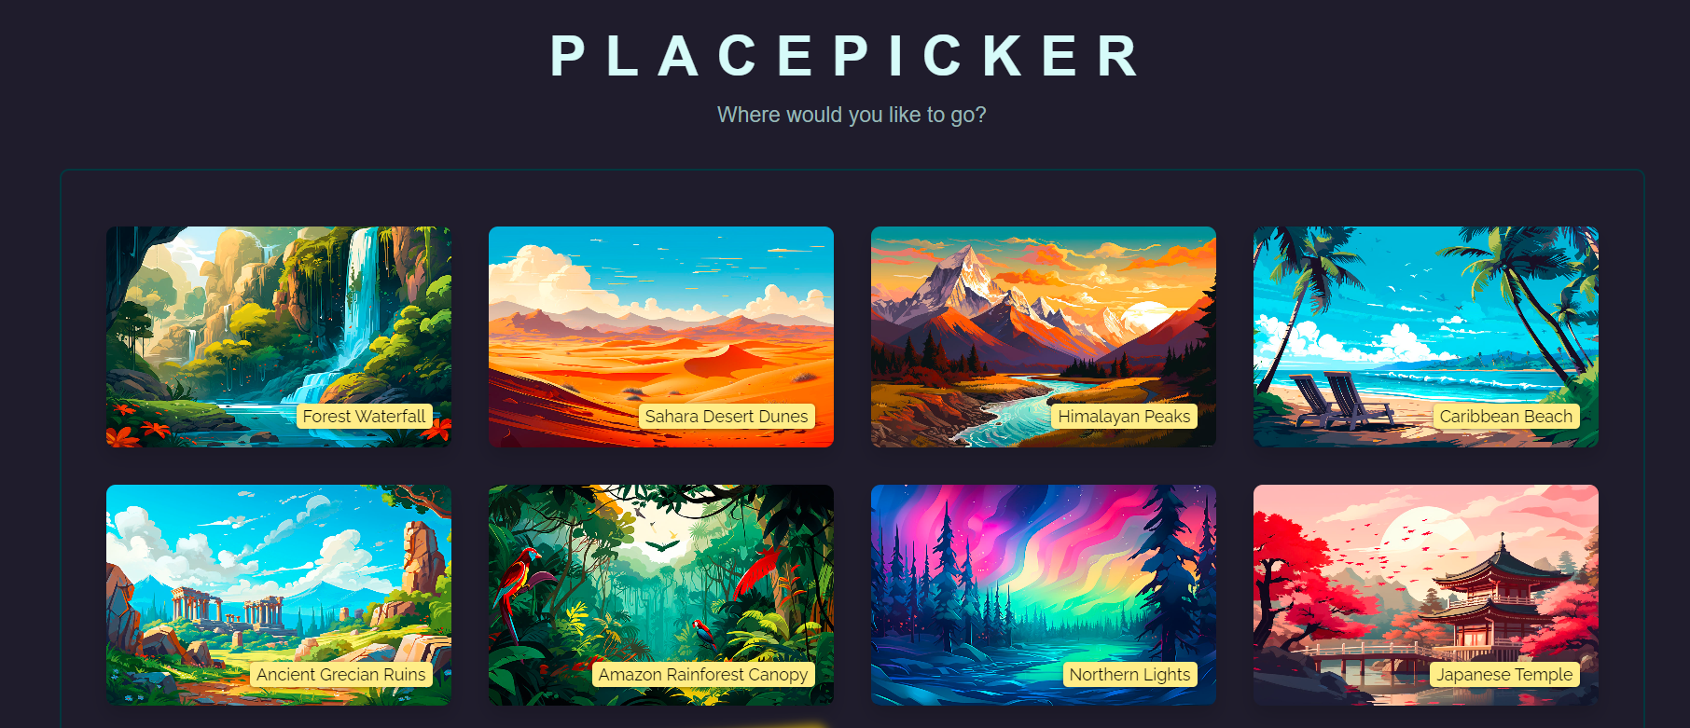

*App will provide a place data to each Place component:*

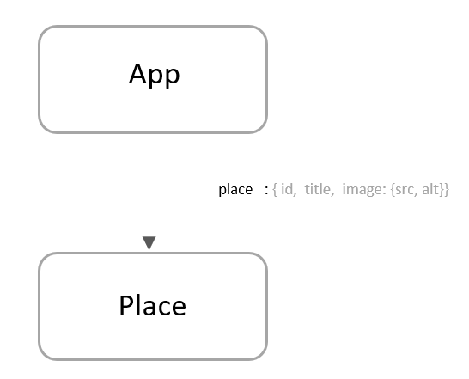

# EXERCISE 5

Amazooooooooooooone!

For this last exercise, you need to show your **creativity**!

1. You need to start from an **empty app.**
2. You are **free** to choose your design and content.
3. Your app shall display a list of cards using a **Card** component. Each card shall contain:

* A picture of someone or something
* Extra information (for example: *name, hobbies, gender, address, price…)*

1. All data shall be stored in the file: **data.js**

 *Are you lost in CSS and HTML?*

We have provided an example of HTML/CSS code in the following folder: **html-sample-code**

*Example*

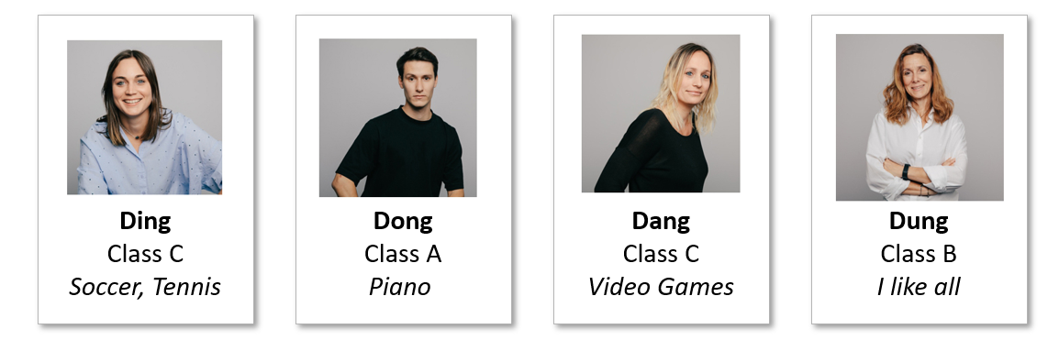

*App will use a Card component to display the items:*

